Today's IELTS word is "breathe."

Definition: (verb) To take air into the lungs and then expel it, especially as a regular physiological process.
Phrase: Breathe deeply.
Usage in a sentence: When she reached the top of the hill, she had to stop to breathe deeply.
Usage in a paragraph: After a long day at work, Jane decided to relax in her garden. She sat on a bench, closed her eyes, and focused on her breathing. She took slow, deep breaths, inhaling the fresh air and exhaling any tension. The sound of rustling leaves and chirping birds added to the serene atmosphere. Jane found that this simple act of breathing deeply helped her unwind and feel more connected to the natural world around her.
Memory Aid: Imagine a person sitting in a peaceful garden, taking slow and deep breaths to relax.
Visual Image for Better Retention: Picture a serene garden setting with a person sitting calmly, eyes closed, taking deep breaths. There's a gentle breeze, and the surrounding greenery enhances the feeling of tranquility.
Now, let's create a visual representation of this scene to aid in remembering the word "breathe."

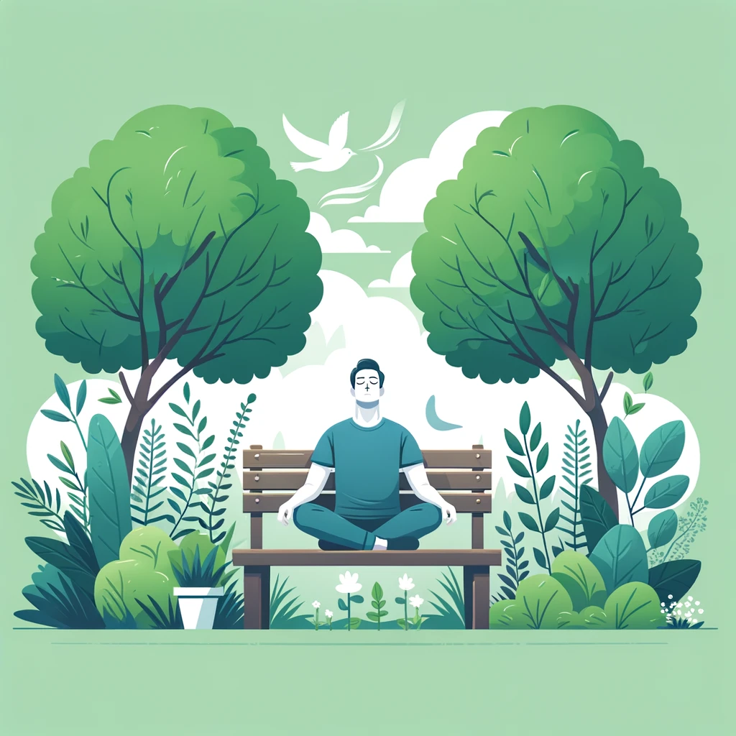
Generated by DALL·E
Here is the visual representation of the word "breathe" in the context of a serene garden setting. This image can help in remembering the word and its usage by associating it with the peaceful act of deep breathing in a calm, natural environment.

